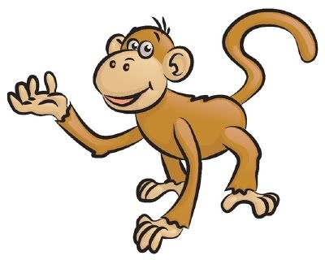
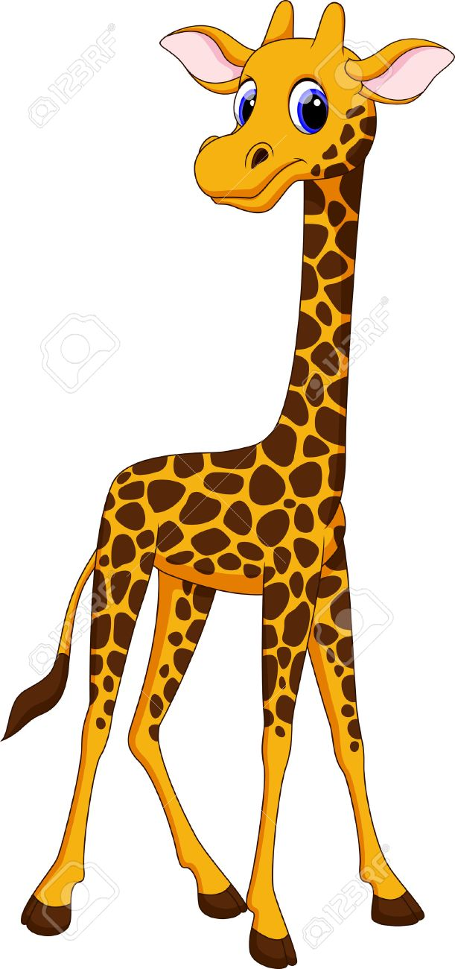
Math Project: Design Your Own Zoo

You have been chosen as a member of a design team to create plans for a new zoo just outside of Calgary. Use the checklist and guidelines to design your zoo. You must use your land and space efficiently and effectively, respecting all the dimensions yet having as many types of animals and shapes as possible.

Design a Zoo Requirements and Notes

The following bullet points are all points you must include to have a complete zoo design.

You must CALCULATE and JUSTIFY:
- The total square area for each enclosure and indicate dimensions. *Be sure to accommodate the total square area PER animal in EACH enclosure

- The total perimeter for each enclosure and indicate dimensions

- The volume or capacity for each enclosure where appropriate. You must include at least 3 enclosures where you have to calculate volume/capacity.

You must INCLUDE:
- You must include 10 different types of animals and you must include at least 2 of each type
- You must label 2 pairs of each type of line (parallel, perpendicular, intersecting, horizontal, vertical)

- Animals that require different types of closures; fences, tanks, pools, etc.

- Pathways to visit each animal enclosure and bonus area that are a minimum of 3 squares wide

- Bonus areas: You must include at least two areas that are non-animal related. Ex: gift shops, concession stands, restrooms, etc.

You must COMPLETE:
- A blueprint on grid paper

- Calculation page for each exhibit and bonus space

- Provide a legend and compass rose

- A self-assessment and self-reflection at the end of your project

Design a Zoo Checklist
☐ Choose at least 10 different animals to include in your zoo.
☐You must have at least 2 of each animal in your enclosure (you can have more, but make sure you accommodate the amount of space in your enclosure to accommodate the number of animals).
☐Include the pathways (walkways) between enclosures
☐Use the provided charts to determine the number of square meters required for each enclosure.
☐Complete blueprint on grid paper, including animal enclosures, pathways and bonus areas
☐Complete area, perimeter and volume sheet

